**C-DAC Mumbai Date 29/09/2024**

**Subject: Algorithm and Data Structure**

**Assignment 3**

**1. Implement a Stack using an array.**

* **Test Case 1**:  
  Input: Push 5, 3, 7, Pop  
  Output: Stack = [5, 3], Popped element = 7
* **Test Case 2**:  
  Input: Push 10, Push 20, Pop, Push 15  
  Output: Stack = [10, 15], Popped element = 20

class Q1{

int max = 10;

int top;

int arr[] = new int[max];

Q1(){

top = -1;

}

boolean isEmpty(){

return (top < 0);

}

boolean push(int x){

if(top > (max-1)){

return false;

}

arr[++top] = x;

return true;

}

void pop(){

if(top < 0){

System.out.println("Stack is Empty...");

return;

}

else{

System.out.println("Pop Element : " + arr[top--]);

}

}

void show(int index){

if(index < 0){

return;

}

else{

System.out.println(arr[index] + " ");

show (index - 1);

}

}

void display(){

if(isEmpty()){

System.out.println("Stack is Empty...");

}

else{

System.out.println("Stack Elements : ");

show(top);

System.out.println();

}

}

public static void main(String[] args){

Q1 q = new Q1();

q.push(5);

q.push(3);

q.push(7);

/*

q.push(10);

q.push(20);

q.pop();

q.push(15);

q.display(); */

q.pop();

q.display();

}

}

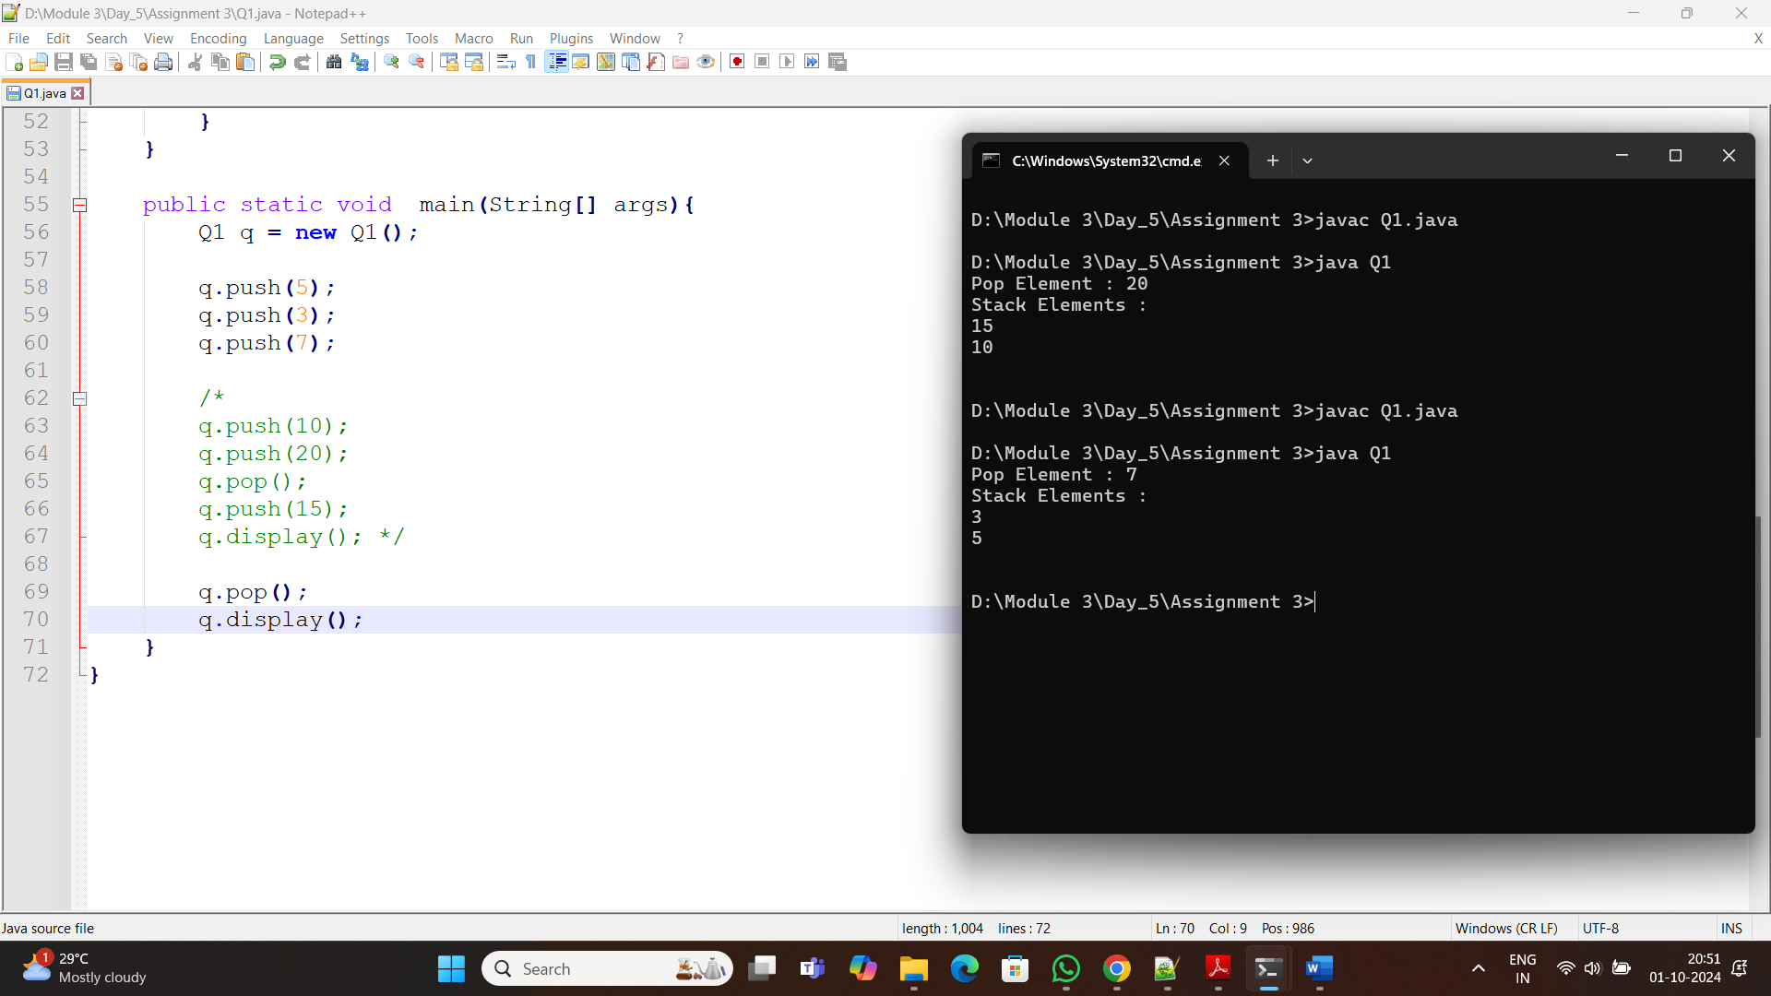

**2. Check for balanced parentheses using a stack.**

* **Test Case 1**:  
  Input: "({[()]})"  
  Output: Balanced
* **Test Case 2**:  
  Input: "([)]"  
  Output: Not Balanced

import java.util.*;

class BalancedParentheses{

@SuppressWarnings({ "rawtypes", "unchecked" })

public static boolean balanced(String input){

Stack s = new Stack();

char[] c = input.toCharArray();

for(int i=0; i<c.length; i++)

{

char current = c[i];

if (current == '(' || current == '[' || current == '{'){

s.push(current);

continue;

}

if(s.isEmpty()){

return false;

}

char popchar;

switch(current){

case ')':

popchar = (char)s.pop();

if(popchar != '(')

return false;

break;

case ']':

popchar = (char)s.pop();

if(popchar != '[')

return false;

break;

case '}':

popchar = (char)s.pop();

if(popchar != '{')

return false;

break;

}

}

return (s.isEmpty());

}

public static void main(String[] args){

Scanner sc = new Scanner(System.in);

System.out.print("Input : ");

String s = sc.nextLine();

System.out.print("Output : ");

if(balanced(s)){

System.out.println("Balanced");

}

else{

System.out.println("Not Balanced");

}

}

}

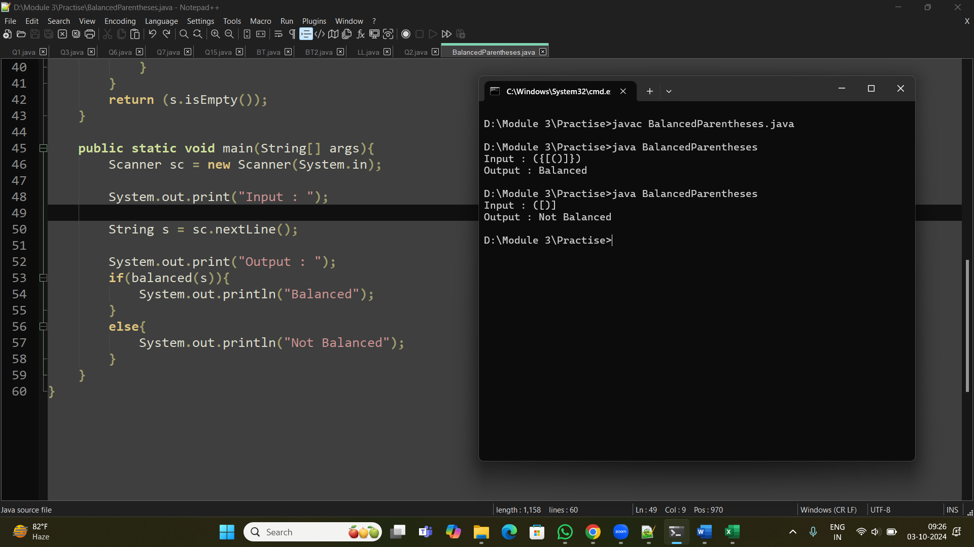

**3. Reverse a string using a stack.**

* **Test Case 1**:  
  Input: "hello"  
  Output: "olleh"
* **Test Case 2**:  
  Input: "world"  
  Output: "dlrow"

import java.io.*;

import java.util.*;

class Q3{

public static String reverseString(String str){

char[] c = new char[str.length()];

Stack<Character> s = new Stack<Character>();

for(int i=0; i<str.length(); i++){

s.push(str.charAt(i));

}

int i = 0;

while(!s.isEmpty()){

c[i++] = s.pop();

}

return new String(c);

}

public static void main(String[] args){

String sr = "hello";

System.out.println("Input : " + sr);

System.out.println("Output : " + reverseString(sr));

String sr1 = "World";

System.out.println("Input : " + sr1);

System.out.println("Output : " + reverseString(sr1));

}

}

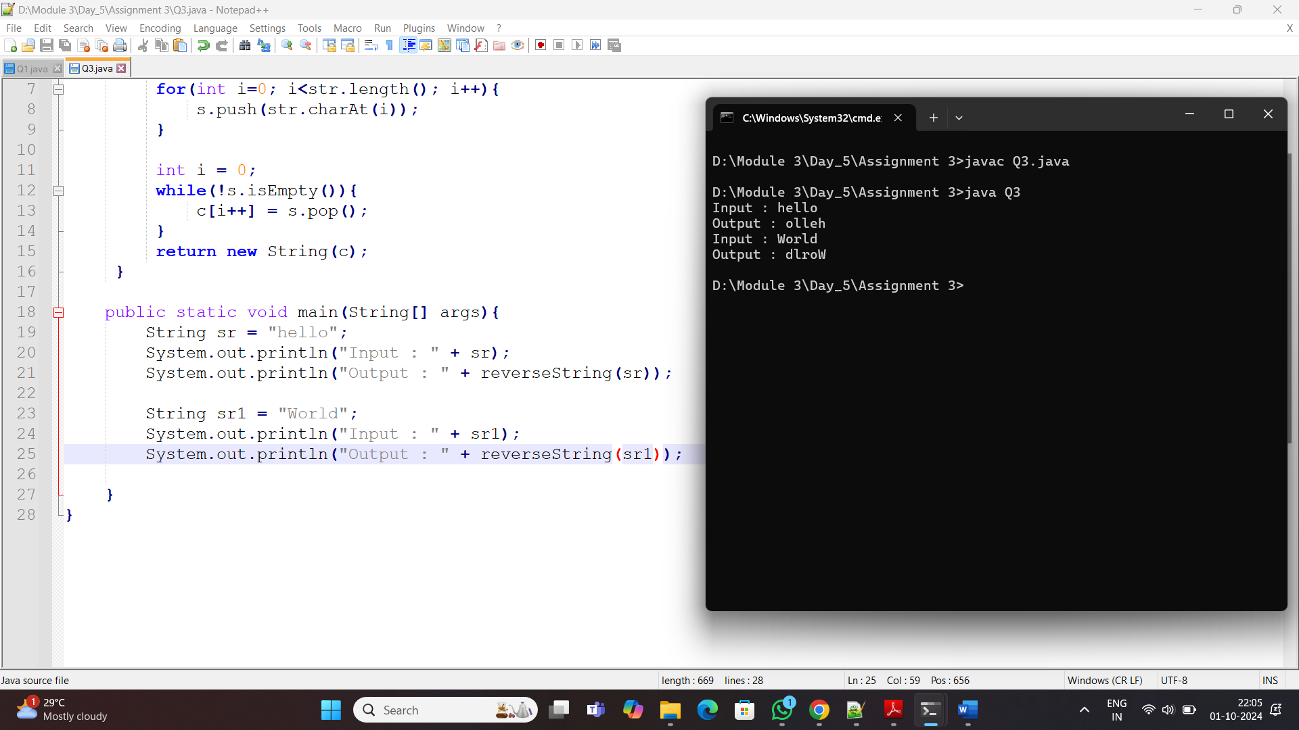

**4. Evaluate a postfix expression using a stack.**

* **Test Case 1**:  
  Input: "5 3 + 2 *"  
  Output: 16
* **Test Case 2**:  
  Input: "4 5 * 6 /"  
  Output: 3

import java.util.*;

class Q4{

@SuppressWarnings({"rawtypes", "unckecked"})

public static int postexp(String str){

Stack<Integer> st = new Stack<>();

for(String s : str.split(" ")){

if(isNumeric(s)){

st.push(Integer.parseInt(s));

}

else{

int op1 = st.pop();

int op2 = st.pop();

switch(s){

case "+":

st.push(op2 + op1);

break;

case "-":

st.push(op2 - op1);

break;

case "*":

st.push(op2 * op1);

break;

case "/":

st.push(op2 / op1);

break;

}

}

}

return st.pop();

}

private static boolean isNumeric(String str){

return str.matches("-?\\d+(\\.\\d+)?");

}

public static void main(String[] args){

Scanner sc = new Scanner(System.in);

System.out.print("Input : ");

String s = sc.nextLine();

System.out.println("Output : " + postexp(s));

}

}

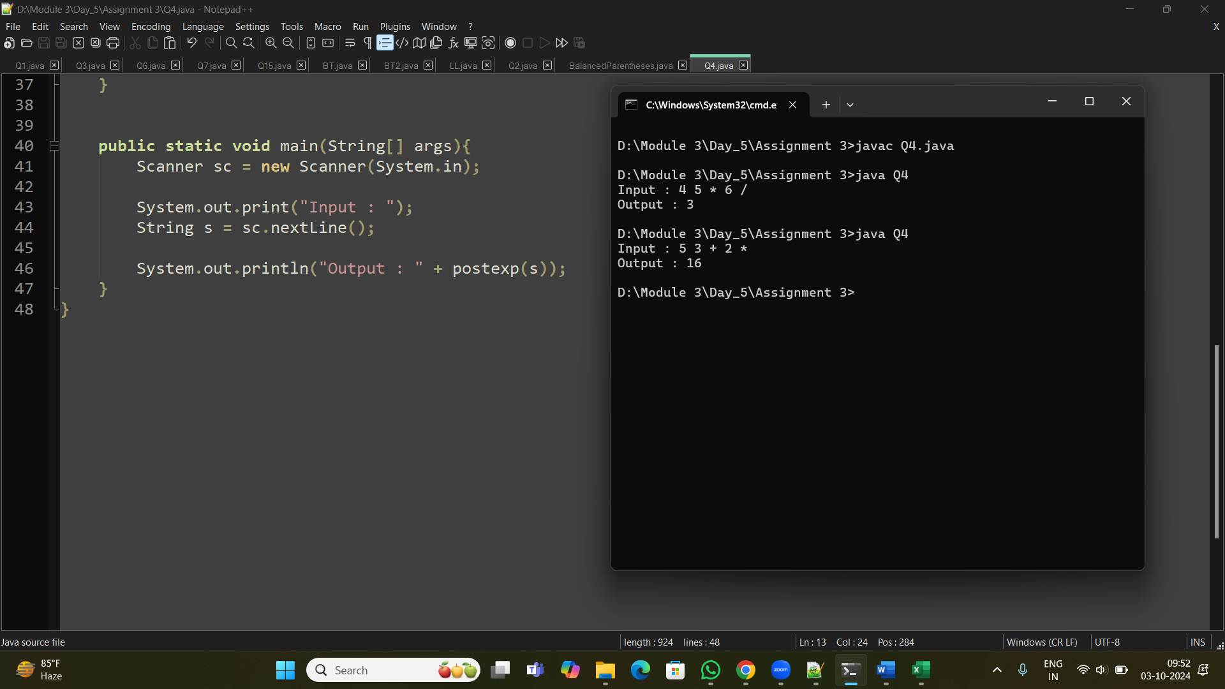

**5. Convert an infix expression to postfix using a stack.**

* **Test Case 1**:  
  Input: "A + B * C"  
  Output: "A B C * +"
* **Test Case 2**:  
  Input: "A * B + C / D"  
  Output: "A B * C D / +"

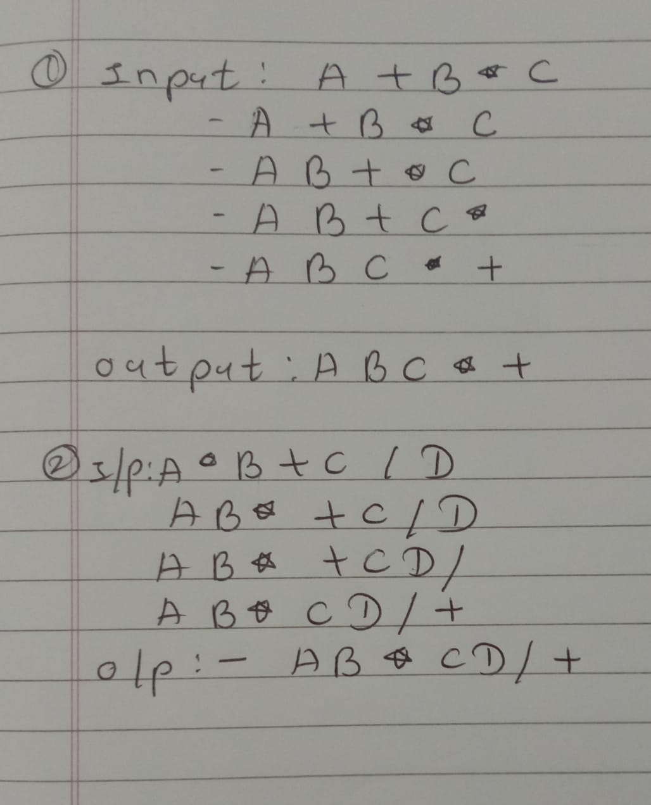

**6. Implement a Queue using an array.**

* **Test Case 1**:  
  Input: Enqueue 5, Enqueue 10, Dequeue  
  Output: Queue = [10], Dequeued element = 5
* **Test Case 2**:  
  Input: Enqueue 1, 2, 3, Dequeue, Dequeue  
  Output: Queue = [3], Dequeued elements = 1, 2

class Q6{

int size = 5;

int Q[] = new int[size];

int front, rear;

public Q6(){

front = -1;

rear = -1;

}

boolean isEmpty(){

return (front == -1 || front > rear);

}

boolean isFull(){

return (rear == size-1);

}

void enqueue(int x){

if(isFull()){

System.out.println("Queue is Full.");

}

else {

if(front == -1){

front = 0;

}

rear++;

Q[rear] = x;

System.out.println(x);

}

}

void dequeue(){

if(isEmpty()){

System.out.println("Queue is Empty..");

}

else{

System.out.println(Q[front] + " removed.");

front++;

if(front > rear){

front = -1;

rear = -1;

}

}

}

void display(){

if(isEmpty()){

System.out.println("Queue is Empty");

}

else{

System.out.println("Queue elements : ");

for(int i=front; i<=rear; i++){

System.out.print(Q[i] + " ");

if (i < rear) {

System.out.print(", ");

}

}

System.out.println();

}

}

public static void main(String[] args){

Q6 q = new Q6();

Q6 q1 = new Q6();

q.enqueue(5);

q.enqueue(10);

q.dequeue();

q.display();

System.out.println();

q1.enqueue(1);

q1.enqueue(2);

q1.enqueue(3);

q1.dequeue();

q1.dequeue();

q1.display();

}

}

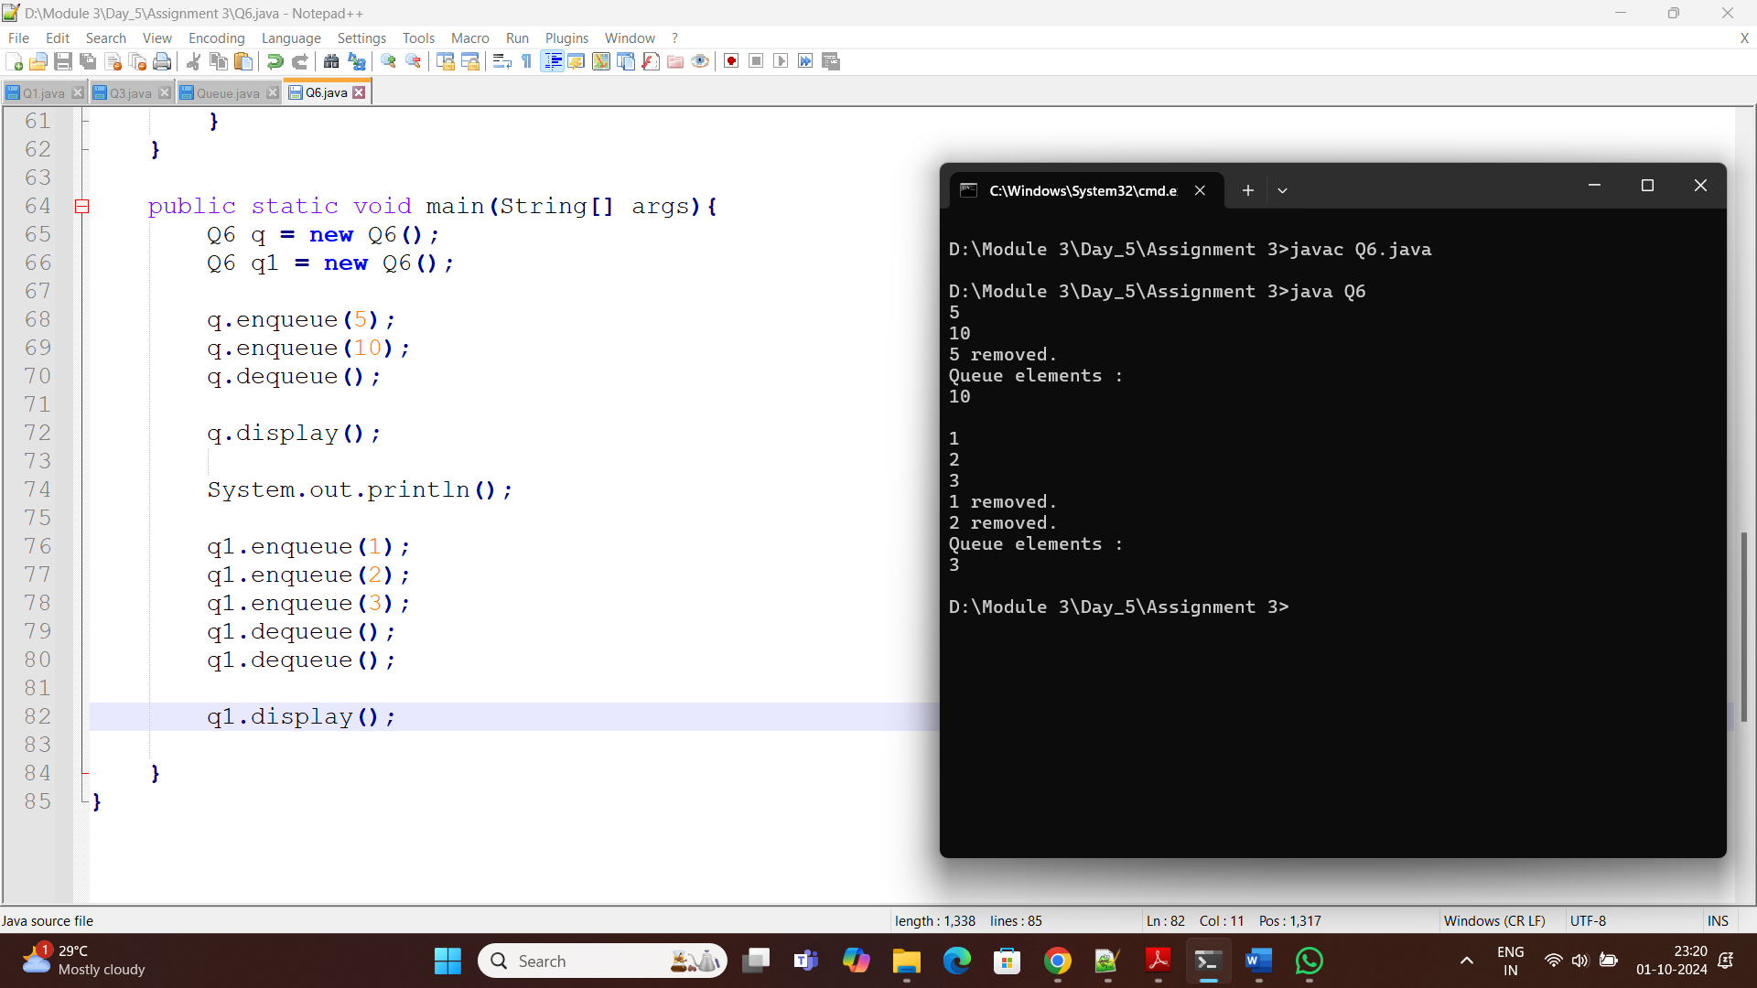

**7. Implement a Circular Queue using an array.**

* **Test Case 1**:  
  Input: Enqueue 4, 5, 6, 7, Dequeue, Enqueue 8  
  Output: Queue = [8, 5, 6, 7]
* **Test Case 2**:  
  Input: Enqueue 1, 2, 3, 4, Dequeue, Dequeue, Enqueue 5  
  Output: Queue = [5, 3, 4]

class Q7{

int size = 5;

int[] Q = new int[size];

int front, rear;

Q7(){

front = -1;

rear = -1;

}

boolean isEmpty(){

return (front == -1);

}

boolean isFull(){

return ((rear + 1) % size == front);

}

void enqueue(int x){

if(isFull()){

System.out.println("Queue is full.");

}

else {

if(front == -1){

front = 0;

}

Q[++rear] = x;

System.out.println(x);

}

}

void dequeue(){

if(isEmpty()){

System.out.println("Queue is empty.");

}

else{

System.out.println("The element " + Q[front] + " is removed");

front++;

if(front > rear){

front = -1;

rear = -1;

}

}

}

void display(){

if(isEmpty()){

System.out.println("Queue is empty...");

}

else{

System.out.println("Queue Element : ");

for(int i=front; i<=rear; i++){

System.out.print(Q[i] + " ");

}

System.out.println();

}

}

public static void main(String[] args){

Q7 q = new Q7();

q.enqueue(4);

q.enqueue(5);

q.enqueue(6);

q.enqueue(7);

q.dequeue();

q.enqueue(8);

q.display();

System.out.println();

Q7 q1 = new Q7();

q1.enqueue(1);

q1.enqueue(2);

q1.enqueue(3);

q1.enqueue(4);

q1.dequeue();

q1.dequeue();

q1.enqueue(5);

q1.display();

}

}

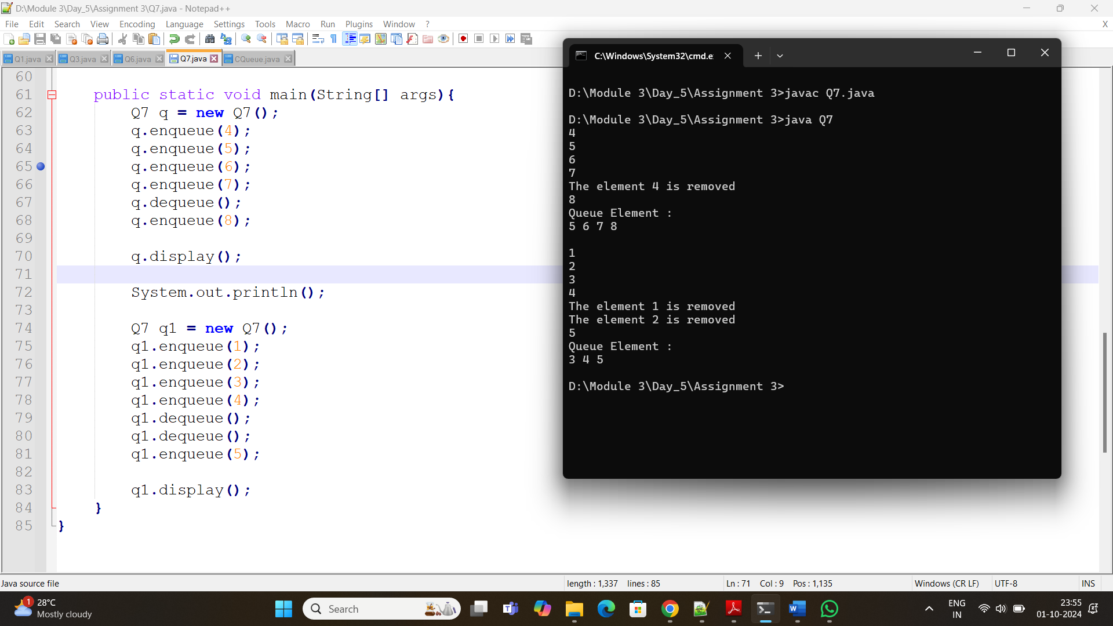

**8. Implement a Queue using two Stacks.**

* **Test Case 1**:  
  Input: Enqueue 3, Enqueue 7, Dequeue  
  Output: Queue = [7], Dequeued element = 3
* **Test Case 2**:  
  Input: Enqueue 10, 20, Dequeue, Dequeue  
  Output: Queue = [], Dequeued elements = 10, 20

import java.util.*;

class Q8{

Stack<Integer> s1 = new Stack<>();

Stack<Integer> s2 = new Stack<>();

void enque(int data){

s1.push(data);

}

int deque(){

if(s2.isEmpty()){

if(s1.isEmpty()){

System.out.println("Empty");

return -1;

}

}

while(!s1.isEmpty()){

s2.push(s1.pop());

}

return s2.pop();

}

void display(){

if(!s2.isEmpty()){

System.out.println("Queue : " + s2);

}

else{

System.out.println("Queue : " + s1);

}

}

public static void main(String[] args){

Q8 q = new Q8();

q.enque(3);

q.enque(7);

q.deque();

q.display();

System.out.println();

Q8 q1 = new Q8();

q1.enque(10);

q1.enque(20);

q1.deque();

q1.deque();

q1.display();

}

}

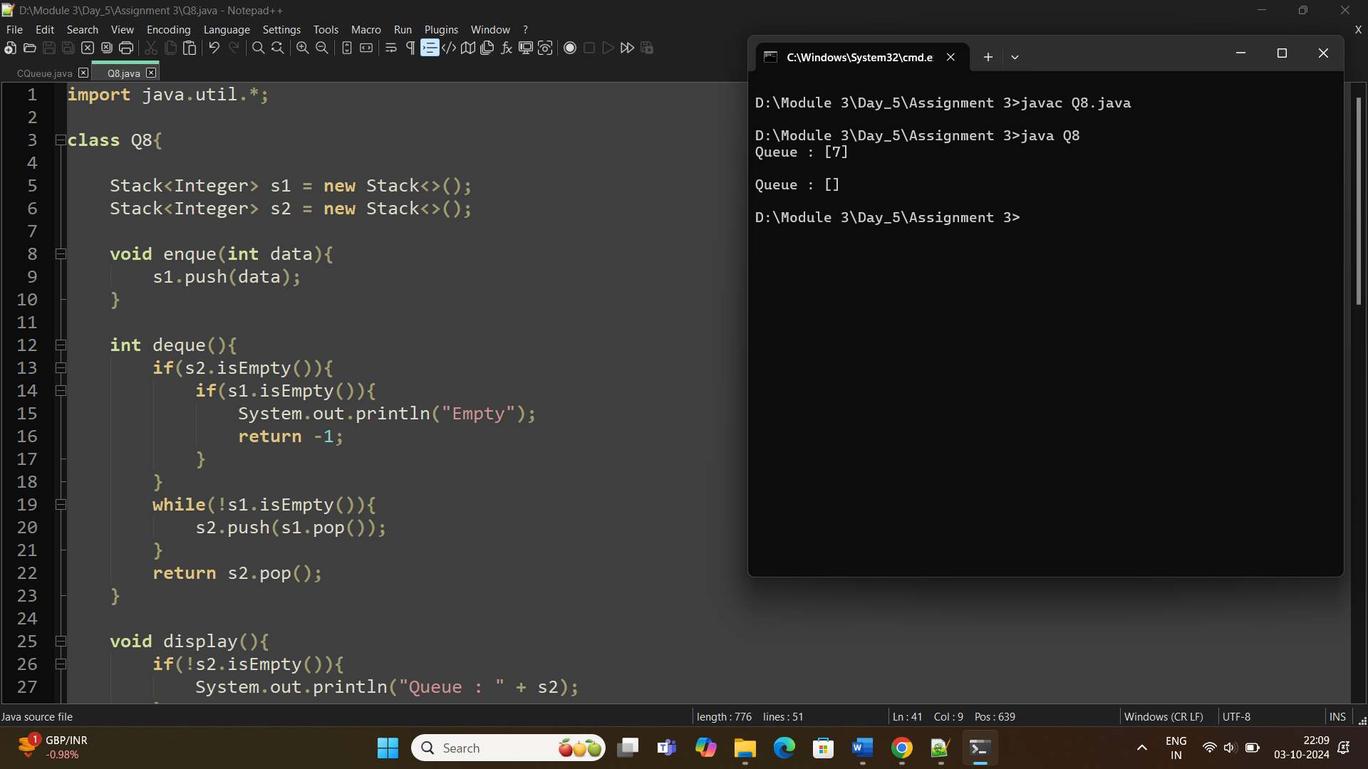

**11. Sort an array using a heap (Heap Sort).**

* **Test Case 1**:  
  Input: [5, 1, 12, 3, 9]  
  Output: [1, 3, 5, 9, 12]
* **Test Case 2**:  
  Input: [20, 15, 8, 10]  
  Output: [8, 10, 15, 20]

class Heapsort{

void heapify(int arr[], int n, int i){

int largest = i; // Root

int l = 2*i + 1; // LC

int r = 2*i + 2; // RC

if(l<n && arr[l] > arr[largest])

largest = l;

if(r<n && arr[r] > arr[largest])

largest = r;

if(largest != i){

int temp = arr[i];

arr[i] = arr[largest];

arr[largest] = temp;

heapify(arr, n, largest);

}

}

void heapsort(int arr[]){

System.out.println();

int n = arr.length;

for(int i=n/2-1; i>=0; i--){

heapify(arr, n, i);

}

for(int i=n-1; i>0;i--){

int temp = arr[0];

arr[0] = arr[i];

arr[i] = temp;

heapify(arr, i, 0);

}

}

void display(int[] arr){

System.out.println();

int n = arr.length;

for(int i=0;i<n;i++){

System.out.print(arr[i] + " ");

}

}

public static void main(String[] args){

Heapsort h = new Heapsort();

int a[] = {5, 1, 12, 3, 9};

System.out.print("Input : ");

h.display(a);

h.heapsort(a);

System.out.print("Output : ");

h.display(a);

System.out.println();

System.out.println();

int ar[] = {20, 15, 8, 10};

System.out.print("Input : ");

h.display(ar);

h.heapsort(ar);

System.out.print("Output : ");

h.display(ar);

}

}

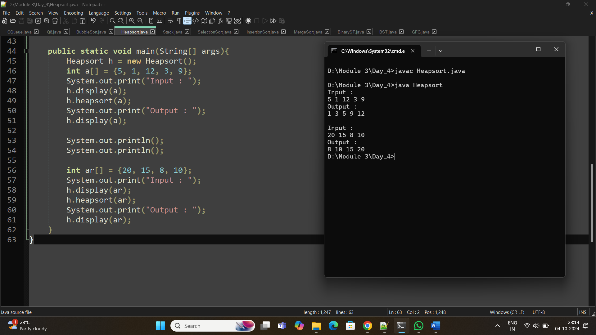

**15. Design a Circular Queue with a fixed size, supporting enqueue, dequeue, and isFull/isEmpty operations.**

* **Test Case 1**:  
  Input: Size = 4, Enqueue 1, 2, 3, 4, isFull()  
  Output: True
* **Test Case 2**:  
  Input: Size = 3, Enqueue 5, 6, Dequeue, Enqueue 7, isEmpty()  
  Output: False

class Q15{

int[] Q;

int front, rear, size, capacity;

public Q15(int capacity){

this.capacity = capacity;

Q = new int[capacity];

front = -1;

rear = -1;

size = 0;

}

boolean isEmpty(){

return size==0;

}

boolean isFull(){

return size==capacity;

}

void enqueue(int x){

if(isFull()){

System.out.println("Queue is full");

}

else{

if(front == -1){

front = 0;

}

rear = (rear+1) % capacity;

Q[rear] = x;

size++;

System.out.println(x);

}

}

void dequeue(){

if(isEmpty()){

System.out.println("Queue is Empty");

return;

}

else{

System.out.println("The element " + Q[front] + " is removed.");

front = (front+1) % capacity;

size--;

}

}

void display(){

if(isEmpty()){

System.out.println("Queue is Empty");

}

else {

System.out.println("Queue Elements :");

for(int i=front; i<=rear; i++){

System.out.print(Q[i] + " --> ");

}

System.out.println();

}

}

public static void main(String[] args){

Q15 q = new Q15(4);

q.enqueue(1);

q.enqueue(2);

q.enqueue(3);

q.enqueue(4);

System.out.println("Output : " + q.isFull());

System.out.println();

Q15 q1 = new Q15(3);

q1.enqueue(5);

q1.enqueue(6);

q1.dequeue();

q1.enqueue(7);

System.out.println("Output : " + q1.isEmpty());

}

}

